Project Name:
Amazon Laptop sales Dashboard
Date: 12/04/2025, Monday

Done by
D s kamali

Agenda

Introduction ----------------------------------------------- 1
Overview of Dashboard ------------------------------------ 2
Benefits of Dashboard -------------------------------------- 3
Technologies used ------------------------------------------- 4
Dashboards ------------------------------------------ 5,6,7,8,9
Conclusion ------------------------------------------------- 10

Introduction

Amazon Laptop sales Dashboard

- A Amazon Laptop sales Dashboard offer a comprehensive the laptop sales performance across the amazon platform
- It is great way to connect with Data analyst , PowerBI developer , PowerBI architect to learn the slicers , performance analysis , analyzing market trends, Customer ratings, pricing trends and user can interactive easily
- This project involved building Designed Dashboards
- In project we can analysis current sales , trends , stock analysis and other requirements
- This tool provide the clarity needed to smart , Data-driven decisions

Overview of Dashboard

Amazon Laptop Sales Dashboard

- The Amazon Laptop sales Dashboard is an interactive PowerBI dashboard that visualizes key metrics related to laptop sales on the amazon platform
- It is designed to help user understand sales performance and make informed decision with real-time data
- Dashboard Highlights
- Sales performance: Unit sold, average selling price
- Top brands & Models : Identify the most popular laptop brands
- Customer insights : Analyze average ratings , customer satisfaction
- Price distribution: How laptop are performing across the India

Benefits of Dashboard

Amazon Laptop sales dashboard

list of benefits of the Amazon Laptop Sales Dashboard:

✅ Benefits of the Amazon Laptop Sales Dashboard
- Data-Driven Decision Making
Get clear, visual insights into sales performance, customer behavior, and product trends to make smarter business decisions.
- Real-Time Performance Tracking
Monitor sales, revenue, and customer feedback in real time, enabling quick responses to market shifts.
- Identify Best-Selling Products
Easily spot top-performing laptop brands and models to focus marketing and inventory efforts.
- Understand Customer Preferences
Analyze customer ratings and reviews to improve product listings and enhance customer satisfaction.
- Optimize Pricing Strategy
Use price segmentation insights to align pricing with customer demand and maximize profitability.
- User-Friendly & Interactive
Interactive filters and visuals make it easy to explore the data from different angles—no technical skills required.
- Improved Inventory Management
Anticipate high-demand products and plan stock levels more accurately, reducing overstock and stockouts.
Technologies used

Amazon Laptop sales dashboard
- Microsoft Power BI
  - Used to design interactive dashboards and visualizations.
  - Supports dynamic filtering, slicers, drill-downs, and responsive visuals.
- Power Query (M Language)
  - For data cleaning, transformation, and loading from various sources.
  - Helps shape raw data into an analysis-ready format.
- Excel / CSV Data Source (or optional SQL Database)
  - Sales data was imported from structured sources like Excel or CSV files
- Amazon Product Dataset
  - Data includes product name, brand, price, ratings, reviews, and sales figures.

Amazon laptop sales dashboards
- Amazon Laptop sales on Excel workbook
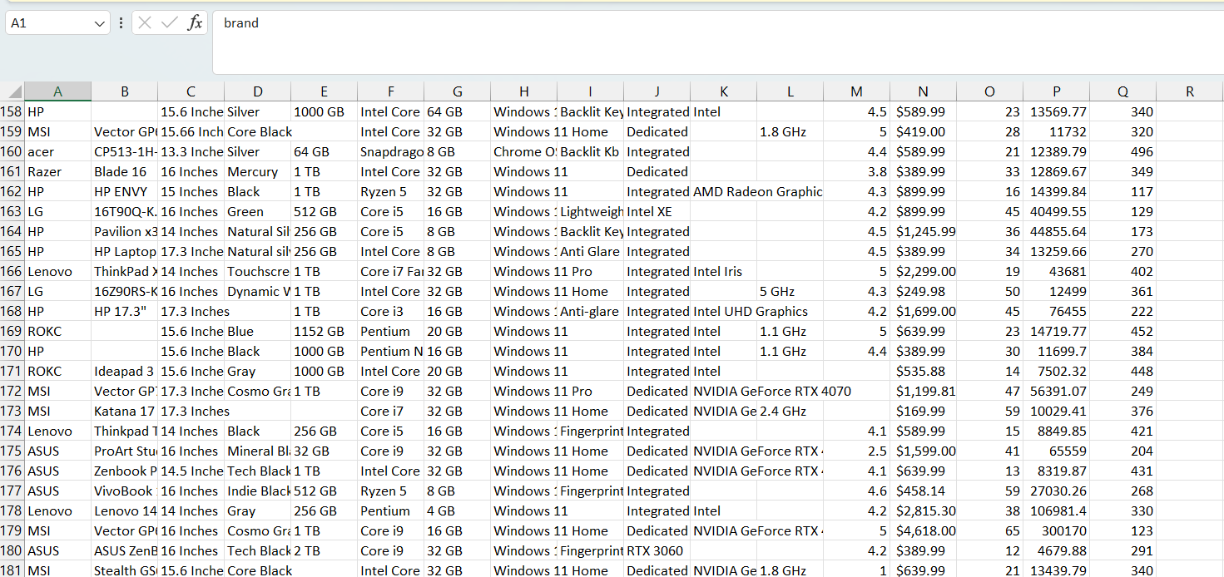

Import Excel workbook transform to Power query editor
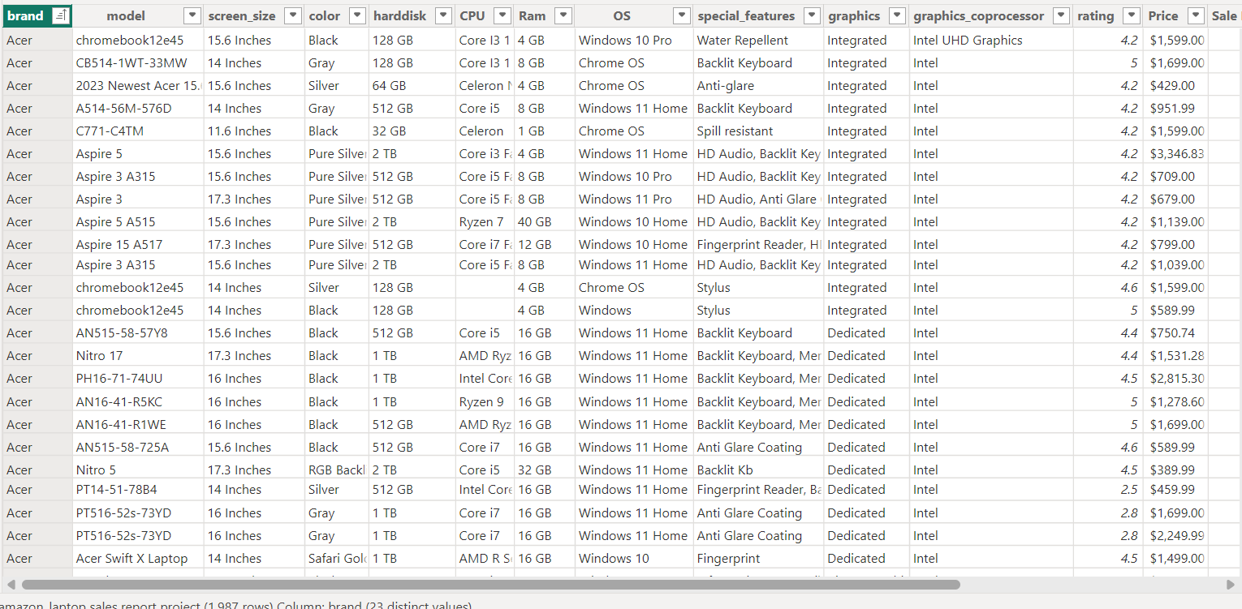
Check the data, cleaning the data and checking the missing values, duplicate values and making Interactive Dashboard
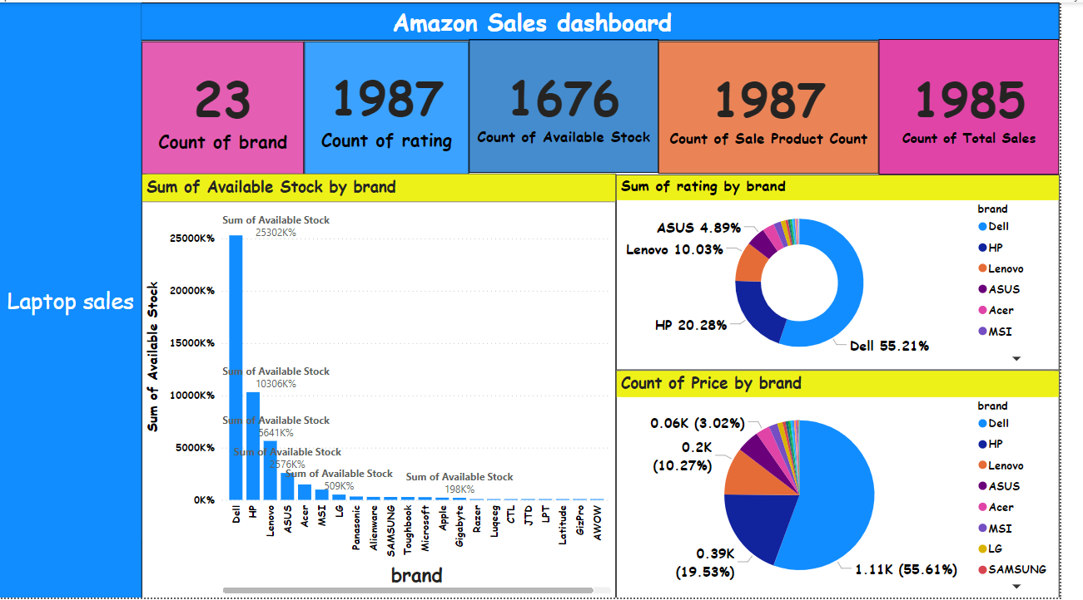

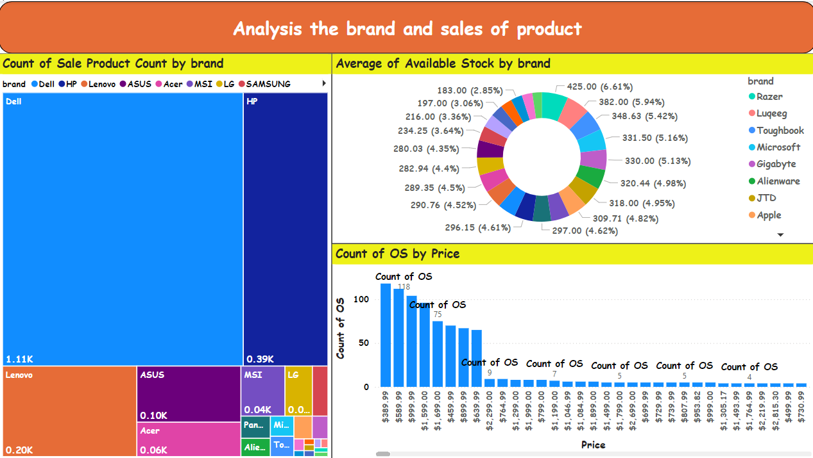

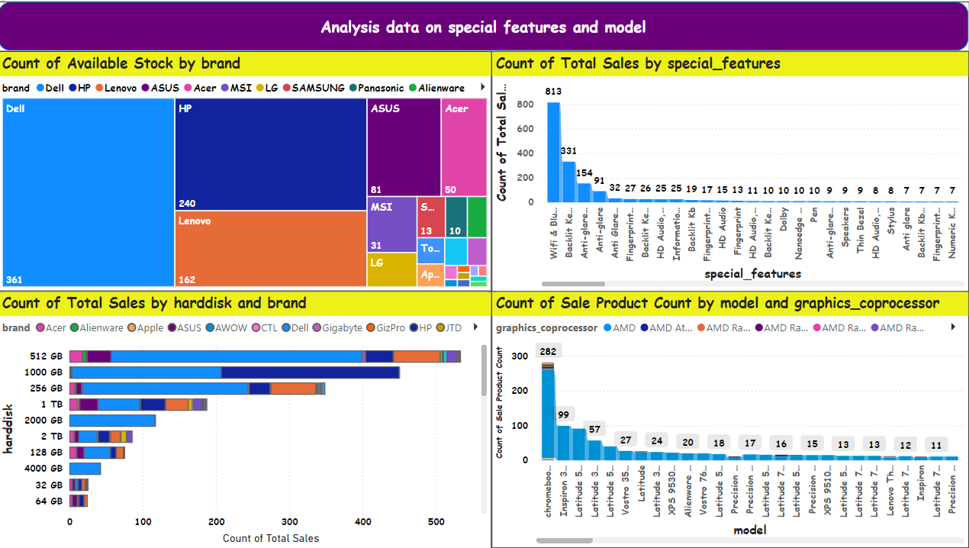

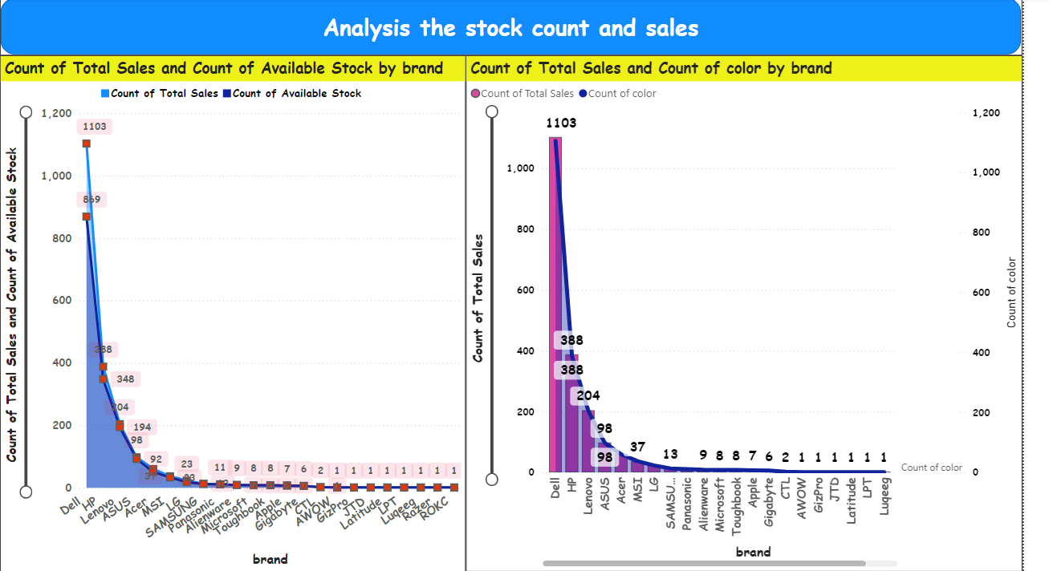

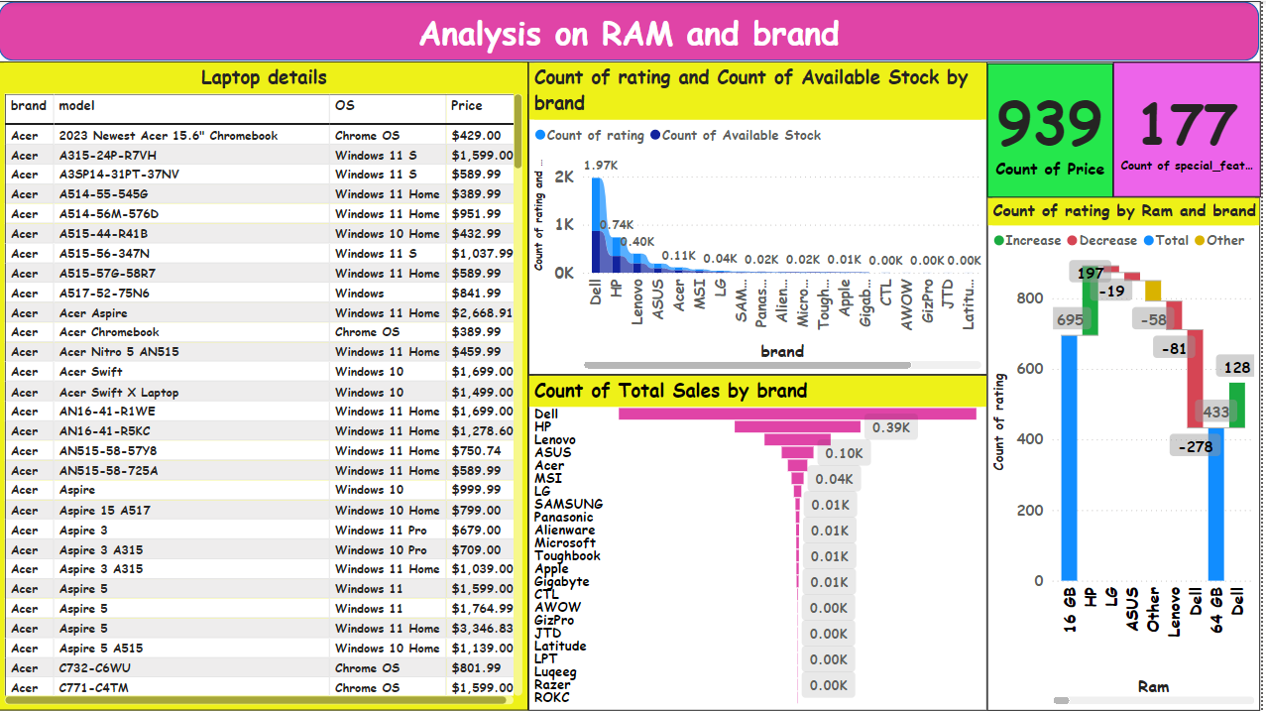

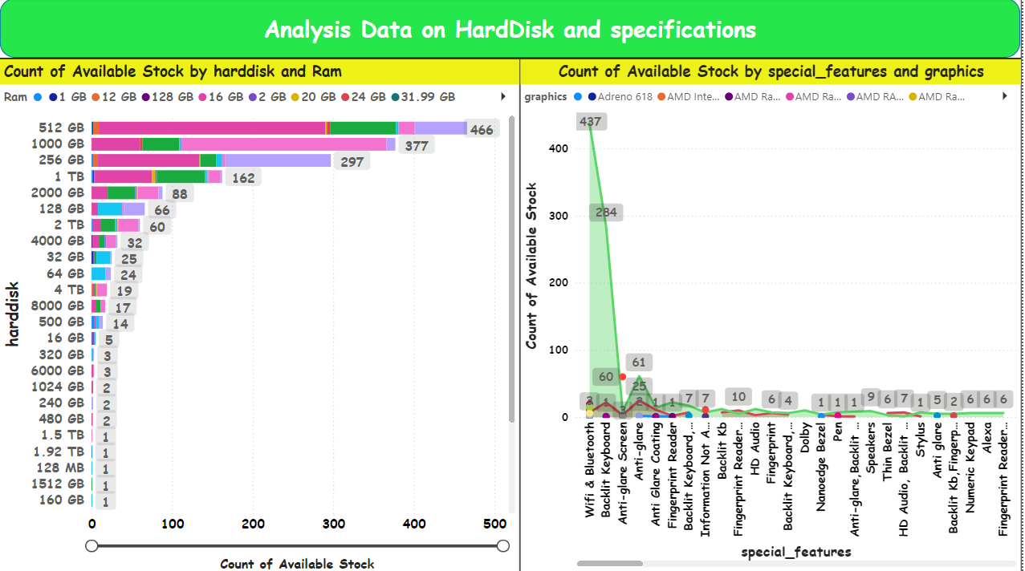

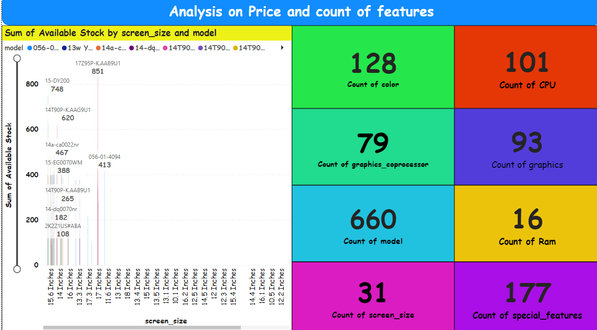

Conclusion

Amazon Laptop sales Dashboard
- The Amazon Laptop Sales Dashboard provides valuable insights into sales performance, customer preferences, and market trends.
- Key highlights include top-performing brands, best-selling models, price ranges with the highest demand, and geographic distribution of sales.
- By leveraging these insights, businesses can make informed decisions on inventory planning, pricing strategies, and targeted marketing campaigns.
- Overall, the dashboard serves as a powerful tool for tracking performance and identifying growth opportunities in the competitive e-commerce landscape.

